Copyright reserved

Please turn over



**NATIONAL CERTIFICATE**

**INDUSTRIAL INSTRUMENTS N5**

**17**

**April 2020**

**This marking guideline consists of 6 pages.**

**MARKING GUIDELINE**

**SECTION A: FLOW MEASUREMENTS**

# QUESTION 1

1.1 • The large pipe carries a greater volumetric rate of water flow than the small pipe.✓

* Since the vortex-shedding frequency is proportional to the fluid velocity, the flow velocities in both cases must be the same (given identical bluff body geometries).✓✓
* However, since the larger pipe has a greater cross-sectional area, an identical velocity equates to a greater volume rate of water moving past the

bluff body and sensor.✓✓✓ (6)

1.2 • Primary device or measuring unit

* Secondary device or recording unit (2)

1.3 • Gravity

* Pump (2)

**[10]**

# QUESTION 2

2.1 Q = V1A1 = V2A2✓✓

2,21(



)

= V

2



✓

2,21(✓



)

= V

2

(



0,0141 = 2,827 × 10-3 V2✓

V2 = 4,988 m/s✓ (6)

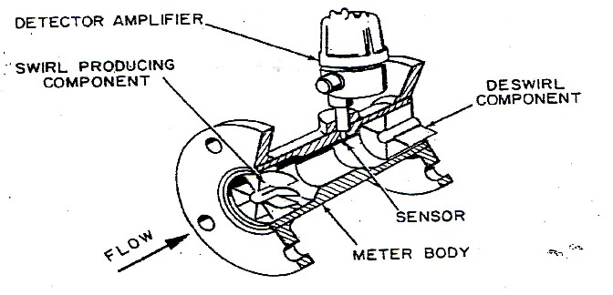2.2 2.2.1

(6)

2.2.2 **Advantages:**

* No moving parts
* Low-pressure losses
* High accuracy

**Disadvantages:**

* Expensive
* In-mounting requirement
* Not accurate in slurry application (3 + 3) (6)

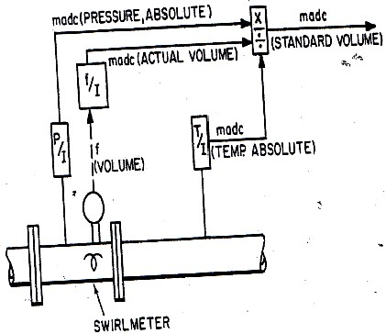 2.2.3

(6)

**[24]**

**TOTAL SECTION A: 34**

**SECTION B: DENSITY, HUMIDITY AND VISCOSITY**

# QUESTION 3

3.1 • In the displacement meter liquid flows continuously through the displacer chamber.

* An upward force acts on the balance beam because of the volume of liquid displaced by the float.
* A pneumatic system balances this upward force and transmits a signal proportional to the density of the liquid.
* Liquids with specific gravities of 0,5 and higher can be measured with this equipment as long as suitable materials are used to prevent damage from corrosion.
* If the temperature of the flowing liquid changes, a thermostat heater may

be used to hold it constant. (5)

3.2 Newtonian fluids: When fluids are deformed by strain the ratio between shear rate and shear stress will be a constant value.✓✓

Non-Newtonian fluids: When fluids are deformed by strain the ratio between shear rate and shear stress will not be a constant value.✓✓

✓

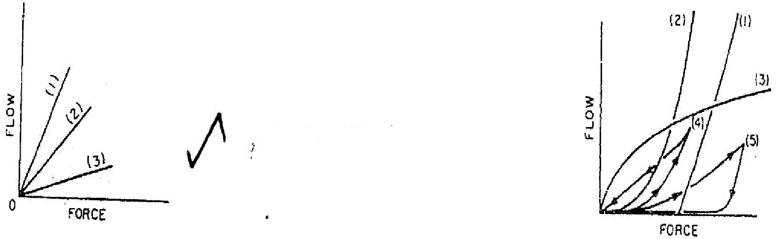

✓

(3 + 3) (6)

3.3 • The instrument should not be mounted near doors or other openings where it will be exposed to artificial drafts.✓ Flush mounting on the panel should be avoided✓ because the atmosphere in the back of the panel is motionless.✓

* The hair element can be mounted on top or on the back of the instrument case depending on the installation.✓
* The element can also be mounted on an extension in the back of the instrument✓ so that the sensing portion is in the room or compartment where relative humidity is to be measured while the readout device is surface mounted on the wall outside.✓✓
* Recorders are generally available as two-pen instruments with the second

pen recording temperature.✓ (8)

3.4 3.4.1

“s”

Rs

R1

R2

R3

Rm

RxRy

AC

VOLTAGE

CONDUCTIVITY

CELL

(6)

3.4.2 Reference conductivity-cell sampling which is a solution of typical composition✓ and subject the same temperature as the measuring cell.✓ Bring a thermistor in contact with the process fluid and

resistor network.✓ (3)

**[28]**

**TOTAL SECTION B: 28 SECTION C: pH MEASUREMENT**

# QUESTION 4

4.1 A screened glass electrode can be used✓ and the electrode assembly✓ must be located at a point where the residual field is smallest.✓ (3)

4.2 The main purpose is to complete the electrical circuit with the glass-membrane electrode.✓ It must provide a stable potential that is relatively invariable,✓ despite changes in either the chemical composition or

physical properties of the process stream.✓ (3)

4.3 Hydroxyl ions (2)

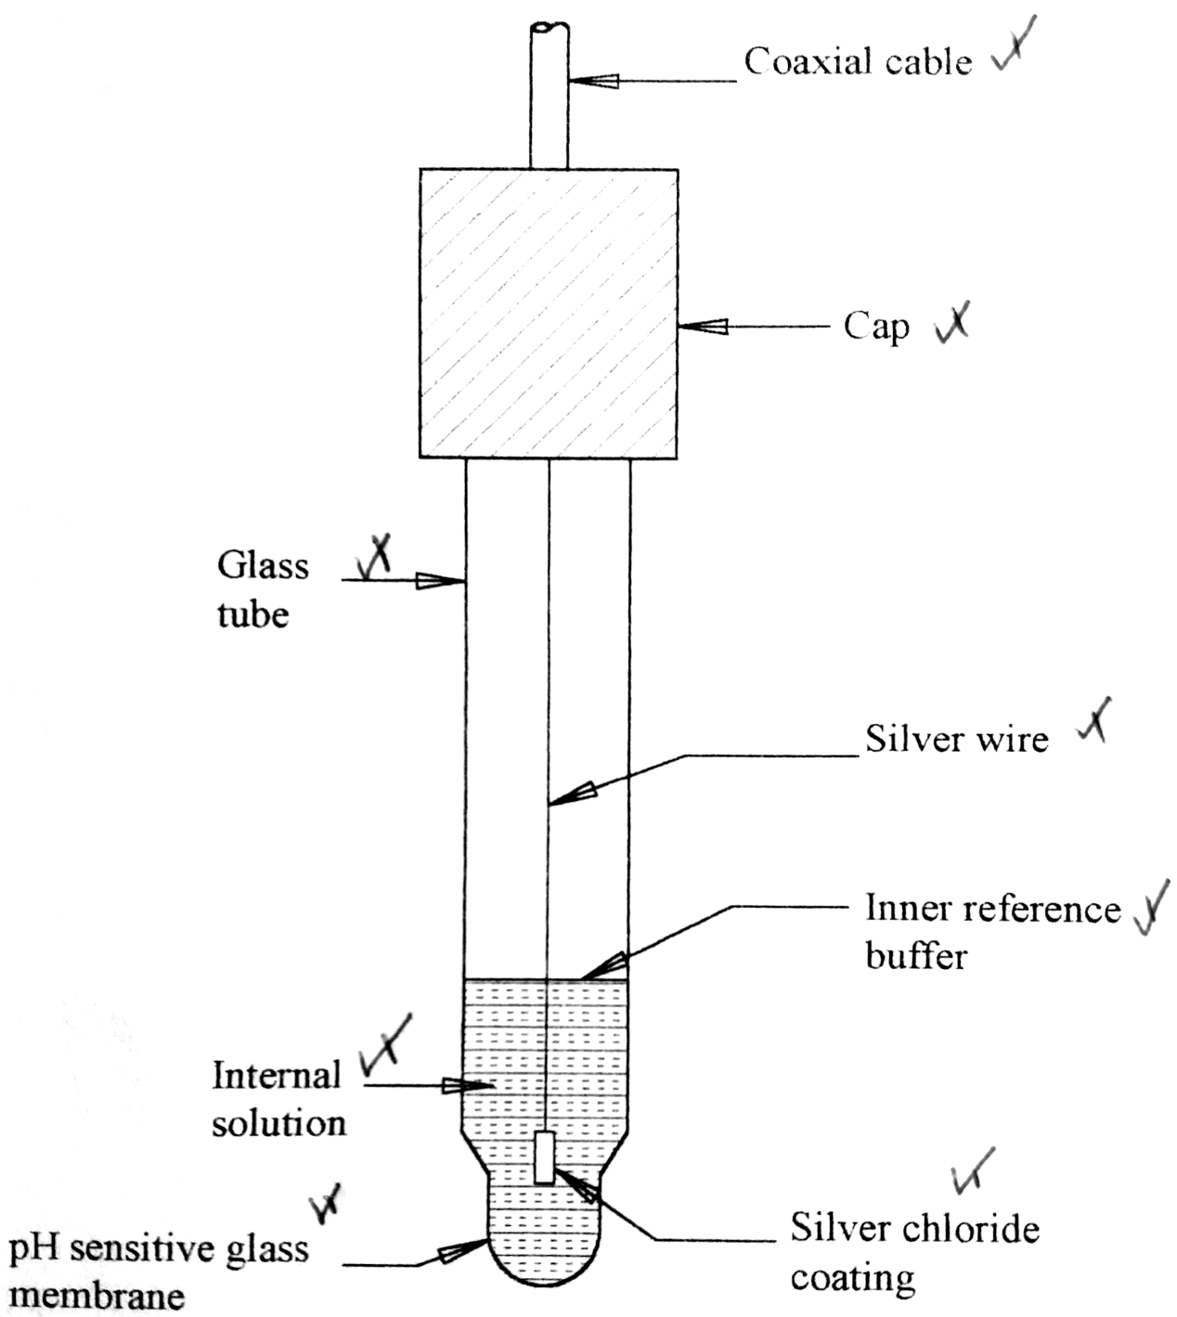4.4

For a glass-membrane electrode to function, both surfaces of the membrane must be hydrated.✓ Hydration occurs by absorption of water by the membrane interface in contact with the solution.✓ There is also an exchange of univalent cations of the glass for hydrogen ions from the solution.✓ At both surfaces of the membrane there will be a boundary potential that will be a function of the hydronium ion activity in the solution at the interface.✓ Because the hydronium ion activity for the internal filling solution is constant,✓ the potential will be a function of the hydronium ion activity of the external solution.✓

(4 for diagram + 6 for discussion) (10)

**[18]**

**TOTAL SECTION C: 18**

**SECTION D: AUTOMATIC CONTROL**

# QUESTION 5

5.1 • All four bellows will have the same pressure.

* The motion pin will be on its true centreline.
* There will be no control actions generated. (3)

5.2 • The output will increase by 10 kPa if the gain is direct.

* Should the gain be indirect the output will decrease by 10 kPa.
* This would be due to the pressure increasing in the process bellows while the pressures in the other bellows stay constant.
* The motion pin will move off its centreline causing the flapper to move either towards or away from the nozzle.
* This should cause the nozzle feedback pressure to either increase or decrease thus causing the output to change accordingly. (5)

* 1. 100% Pb = 100/gain (1)

* 1. By swivelling the gain adjustment dial directly to reverse (1)

* 1. • When the integral action is marked in repeats per minute it indicates that the integral will repeat per minute✓
* When marked in minutes per repeat it indicates the time to repeat the

proportional band✓✓ (3)

5.6 • The derivative action time taken for proportional action to repeat the derivative action for a ramp change✓

* Most controllers do not produce the true theoretical output due to interactions between the control actions✓ and are therefore called

interactions controllers✓ (3)

5.7 **Advantages of a live zero-based signal:**

* Difference between power on and power off
* See movement from zero in both directions
* Two-wire system (no high voltage in hazardous area)

**Advantage of a zero-based signal controller:**

* Mathematical functions are easy, as they do not have to be biased (4)

**[20]**

# TOTAL SECTION D: 20 GRAND TOTAL: 100